Congregational Holiness Church
World Missions
Missionary Internship Program

CHC World Missions Executive Director
Scotty Poole (white shirt) ministering in Brazil.

Thank you for your interest in participating in the Missionary Internship Program. I know that any missionary ministry that you do will have a lifelong impact. God is desiring that people just like you will be willing to follow His call and be an example of Christ throughout this world. My prayer is that God will bless you through your journey with him and I hope that the CHC World Missions Department can have a small part in that.
Blessing & Grace,
Scotty

My contact information:
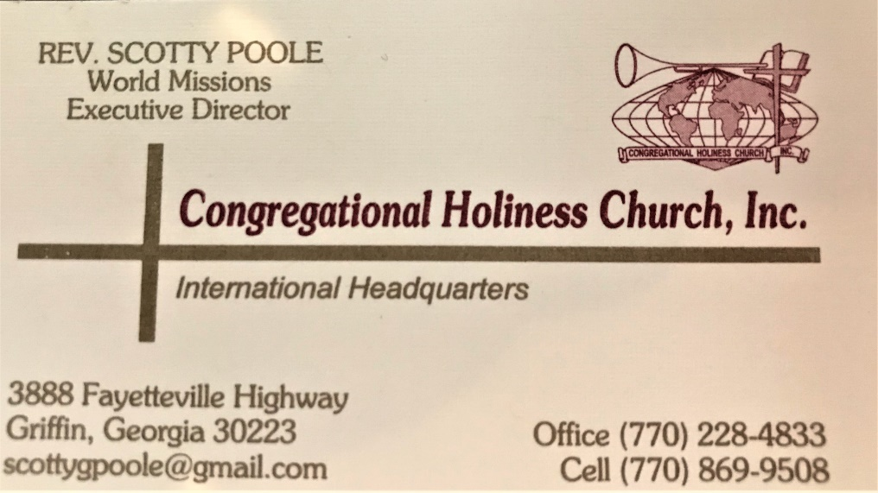
CHC World Mission Missionary Internship Program
“There’s Still One….” PraySendGo!

Why complete a Missionary Internship?
- You can intentionally carry the gospel to another country and be part of the Great Commission!
- You are part of a concentrated effort to pass on what you learned, experienced, and received to the current and next generation!
- It is a highly competitive process and looks great on college applications!
Why you should “PRAY……SEND……..GO!”
Missions needs Prayers.
Matthew 9:38 says “therefore pray earnestly to the Lord of the harvest to send out laborers into his harvest.” As Jesus commands us to pray for workers to enter the fields of the gospel this program will help ignite the passion and desire to see the work completed in the heart of the participant. Even if this becomes the only time you go to an international field it will set in your heart the need for missions to continue! We pray for all those who need Jesus because…………. there is still one!
Missions needs Givers.
Paul writes in Philippians 4:16 “Even in Thessalonica you sent me help for my needs once and again” showing that even in Paul’s day financial support was necessary to complete the work of missions. Completing an internship will help you understand the necessity of giving to World Missions and help you explain how critical giving and sending is to the Great Commission. We send and give for all those who need Jesus because……………. there is still one!
Missions needs Goers.
In Matthew 28:19 Jesus tells us “Go therefore and make disciples of all nations, baptizing them in the name of the Father and of the Son and of the Holy Spirit”. If you are a believer, this message is for you. Everyone is called to go. The mission field is wherever the soles of your shoes meet the ground, but we still need those that are willing to cross oceans and national boundaries to do the work of the ministry. With this program we are investing into the next generations of goers. We are making the step to help others fulfill the call to go and make disciples. We go for all those who need Jesus because…………….. there is still one!

Societies may change but God’s word and commission remains the same.
Technological advances are a blessing and are used to aid us in the promotion of the gospel and the work of missions. However, don’t depend on technology to replace what a face to face testimony can do by the power of the Holy Spirit. World Missions is not just about brick and mortar buildings, it is also about building relationships with each another and with God. We go because we know…….there is still One!

CHC World Missions Missionary Internship Program
There’s Still One….” PraySendGo!

Why is the Missionary Internship Program important to the Christian?
Why Missions?
Because God has called all to the work of the ministry. Missions starts where ever you are - it is not just across oceans in different countries. However, there are those that are called to the international fields to fulfill the call God has given to them. You can learn about different cultures and how God moves among a group of people with a cultural background that is different from the intern. You can also see how God loves all people, not just those that serve Him. Finally, you can see how great the need is throughout the world and understand that if we are blessed to help others. The greatest need in this world is the need of the individual to know Christ as Savior and that is the heart cry of missions to share Jesus in word and deed.
Why an Internship?
The internship exposes the intern to the realities that not everyone in this world has an equal advantage to know, hear, and respond to the gospel. It also gives the intern an opportunity to aid and assist others in their walk with and to Christ. Even if the intern never returns to the international mission field it will forever impact the heart to see the great need for missions to continue until Jesus returns.
What does the Internship mean to/for the CHC?
This internship will be one way in which the passion, love, and continuation of mission work is passed on to our next generation. Paul seemed to always have a young minister that was traveling with him in his mission work. Think of Titus and Timothy and how their exposure to the mission ministry influenced them and continued the mission ministry to the next generation.
What does the internship mean to/for you?
There is no doubt missions ministry is a calling, but this internship can be the avenue God uses to open the intern’s heart to a call He has placed on their life. While serving as an intern, God can give clarity to what He wants you to give your life too. You may realize that you will be a life-long supporter of missions or you may realize you will be a goer to missions. But it is in these moments of serving that you can be led by the Holy Spirit to fulfill your life call. Finally, what this internship will do for you is bless you. Just ask someone who has taken a missions journey. They will tell you, no matter how difficult the task or how hard the work, they returned more blessed than they left. God truly blesses those who are willing.
Here is what missions looks like:
Love one another. Serve one another.
Care for one another. Fellowship one with another.
Missions is about doing what Jesus did -- meeting people. Missions is about people and giving to them what they need, which is Jesus. We minister in word: what we said, how we respond, how we share, how we react. We also minister in deed: how we serve, how we treat, how we minister care, how we love. The giving, serving, loving and locations may change, and the people may be different, but missions is always the same.

CHC World Mission Missionary Internship Program
There’ Still One….” PraySendGo!
Internship
A World Mission Missionary Internship is an opportunity for someone to experience international mission hands on. The intern will be working, worshipping, and ministering in a different culture alongside an experience missionary. The intern will use this experience not only to help others but also to learn from others what it means to serve Christ in an ever-changing world. This internship may help define a calling in the life of the intern or it may simply give a better Christian World-View that will help the intern to become a better Christian. The internship is simply a way in which one can come to understand that serving Christ is about serving and loving others.
The international field the Internship Program is working with is White Fields Missions. WFM is the mission work of Allen and Vicky Skelton in La Ceiba, Honduras. There they minister to children, elderly in nursing home and local village people. Duties will vary with each group of people being ministered to. Intern will also assist Vicky with everyday work around the facilities at White Fields. This is a great opportunity for exposure to mission worker or for someone considering the calling to become a missionary for God. You can check out the work at White Fields at www.whitefieldsmissions.org
Currently one CHC World Mission Missionary Internship scholarship will be given per calendar year.
One-Month Internship
The one-month internship will be served entirely in the international setting. In this program the intern will be required to select the dates he/she can spend at international location and purchase airfare to the location. The expense of staying at the international location including room and board and meals while on WMMIP location and transportation to and from the airport to WMMIP location will be provided by CHC World Missions Department. (Any meals outside of the provide location or spending money for souvenirs or free days must be provide by the intern).

Two-Month Internship
The two-month internship is the same as the one-month internship with an added month (before the international internship) where the intern will serve as an intern at the CHC International Headquarters in Griffin, Georgia. Room and board will be provided. Meals will be the responsibility of the intern.
Duties of the intern will be to aid the office staff and WM Executive Director, Mission USA Executive, and Bishop as needed with office and clerical duties. This internship helps to give the intern an understanding of the administrative duties involved with ministry.
If completing two-month internship, the CHC World Mission Department will cover the airfare to the international location of internship.

Process
Each applicant will be required to complete the CHC World Missions Missionary Internship Application and be interviewed by the CHC World Mission Board. The CHC World Mission Board will make the decision as to which applicant receives the internship scholarship.
If an applicant is not chosen she/he can apply again. If the applicant desired to cover all their own expenses and they meet all the internship requirement the CHC World Mission Board will consider giving him/her recommendation as a traveling intern for the CHC Mission Department.
Requirements
- Must be at least 16 yrs old and a Senior in High School.
- Must be able to spend 1 month at an International Mission work.
- Must have passport. If applicant does not have one, they must begin the process of getting a passport.
- Must be born-again.
- Must be spiritually mature.
- Must have a servant’s heart.
- Must be in agreement with the CHC Statement of Faith.
- Able to take and follow directions.
- Needs to be in good general health.
- Must purchase own airline ticket for trip.
- Submit 3-page typed paper regarding trip within 7 days of returning
- Present ten-minute presentation to your church body in a service regarding the trip and its impact on your life.
- Last,
HAVE A GREAT TIME SERVING THE LORD IN INTERNATIONAL MISSIONS!!!

NOTES:
____________________________________________________________________________________________________________________________________________________________________________________________________________________________________________________________________________________________________________________________________________________________________________________________________________________________________________________________________________________________________________________________________________________________________________________________________________________________________________________________________________________________________________________________________________________________________________________________________________________________________________________________________________________________________________________________________________________________________________________________________________________________________________________________________________________

The CHC World Missions Missionary Internship Program is working toward being accepted for credit toward a college degree.
Health care outside of the USA is not like health care in the US. So, if you have ANY health issues that may become a problem you may want to reconsider a trip of this length.
Unless completing the two-month internship.

